MAPPING TO A NETWORK PRINTER
WIN 7

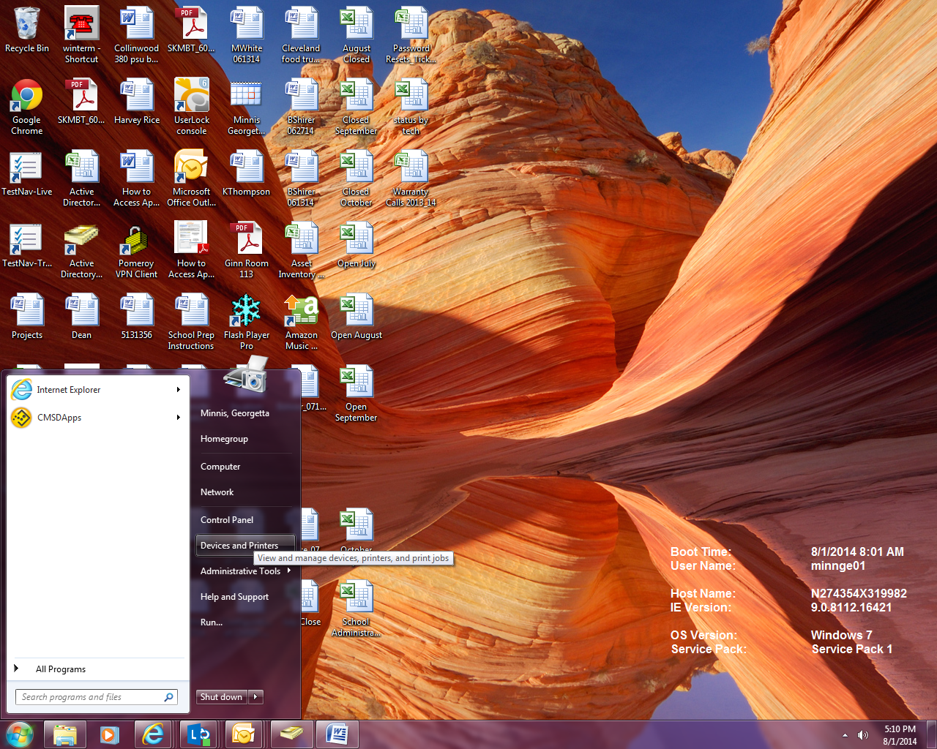
- Click Start, Devices and Printers

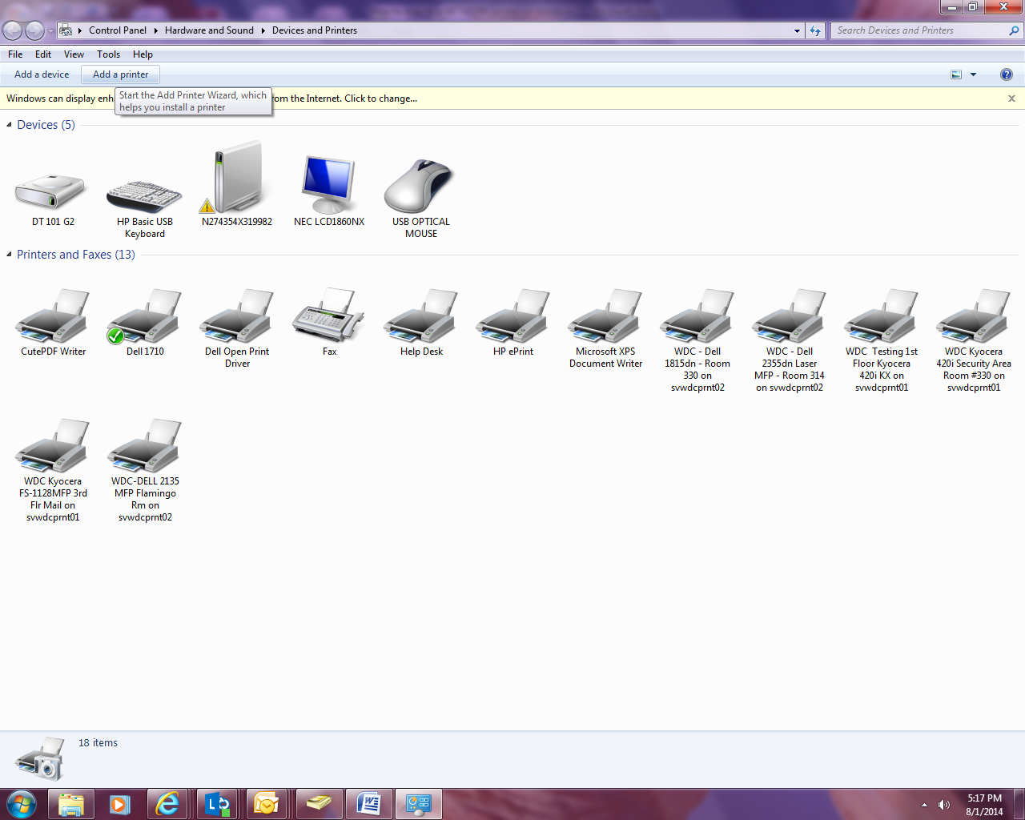
- Click Add a printer

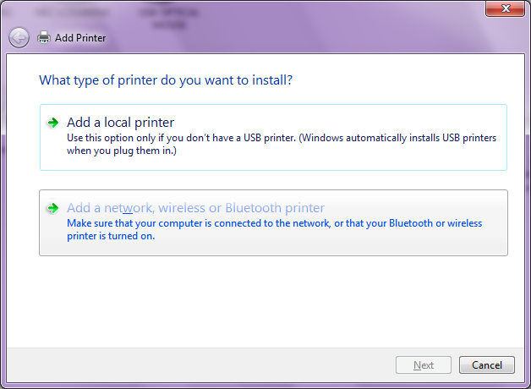
- Click Add a network, wireless or Bluetooth printer

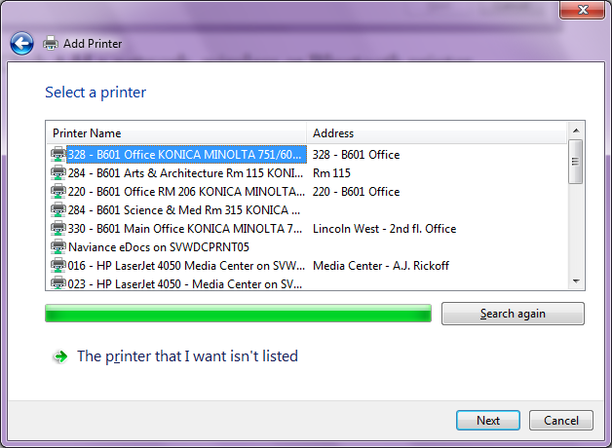
- Click The printer that I want isn’t listed

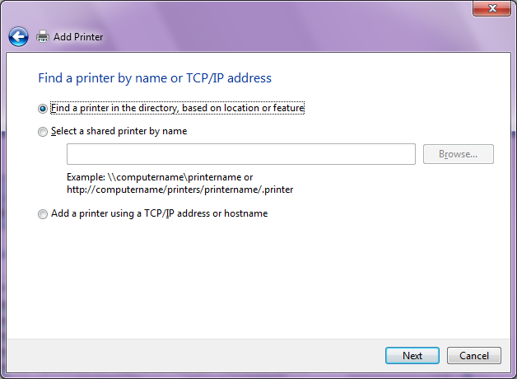

- Choose Find a printer in the directory, based on location or feature
- Click Next

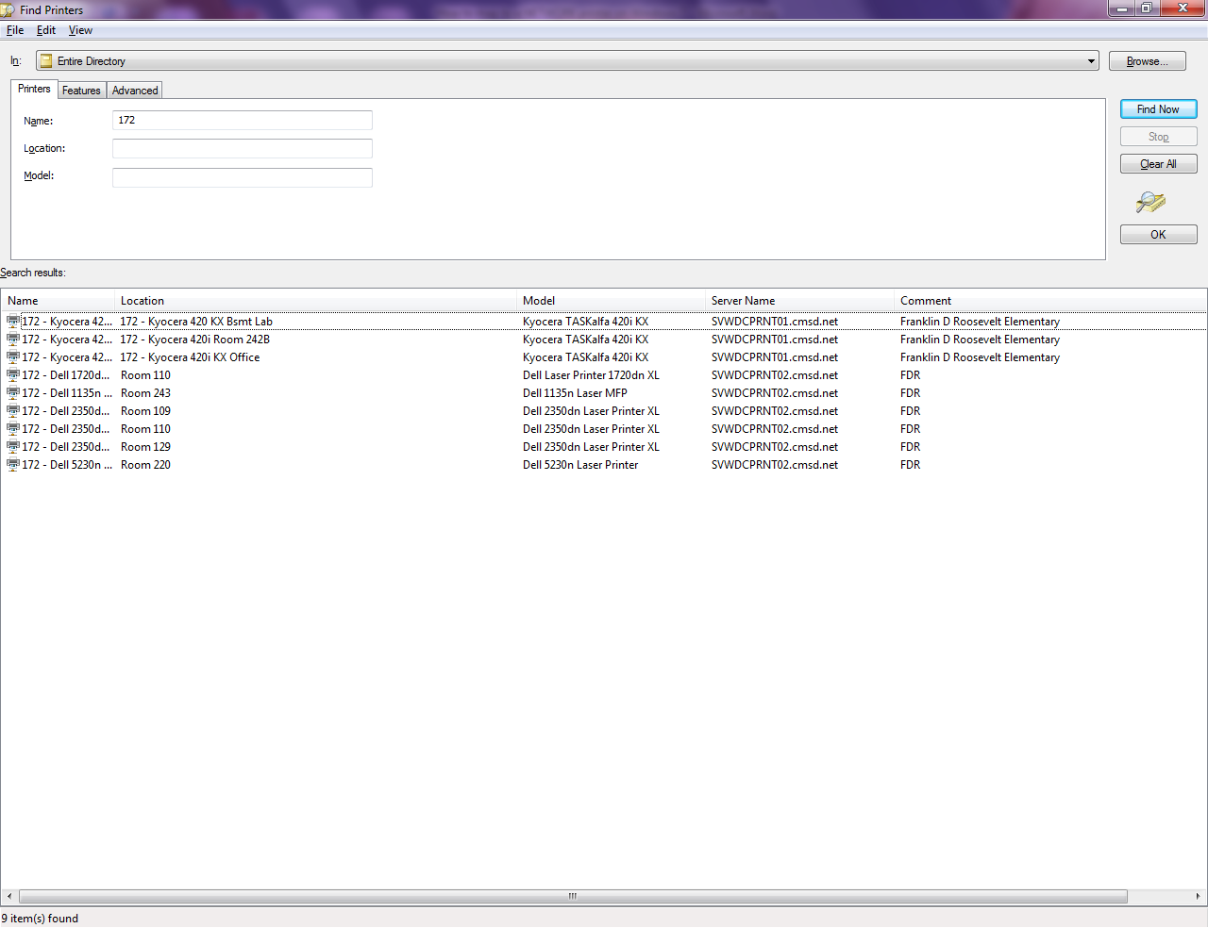
- Enter the 3 digit school code
- Click Find Now
- A list of NETWORK printers will display at the bottom under Search results.
- Double click the desired printer

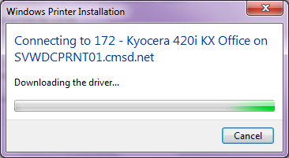

- You should see a dialog box indicating the driver is downloading – IF YOU RECEIVE A PROMPT ASKING YOU TO LOG ON TO THE NETWORK, CONTACT THE HELP DESK TO CONFIRM YOUR NETWORK ACCOUNT HAS BEEN UPDATED WITH YOUR CURRENT SCHOOL ASSIGNMENT.

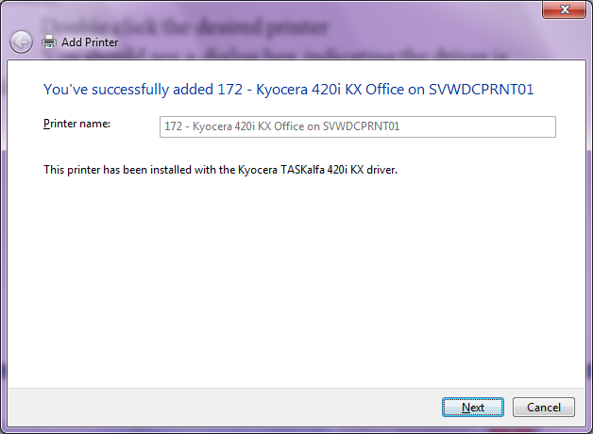

- Click Next

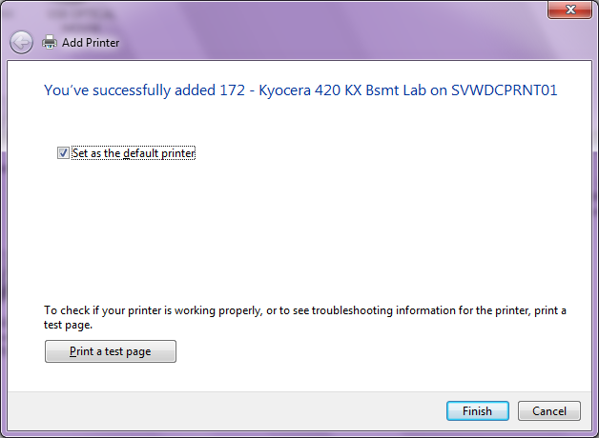

- Choose Set as the default printer if you want your print jobs to always default to this printer, otherwise, do not check the box.
- Click Finish

