PORT REPLICATOR
The PORT REPLICATOR that you received with your Netbook, is a device that attaches to your Netbook. It easily allows you to access network resources as you would on a Desktop computer.
CONNECTING YOUR NETBOOK/LAPTOP TO THE PORT REPLICATOR
- Connect the Port Replicator’s power adapter to the back of the Port Replicator.
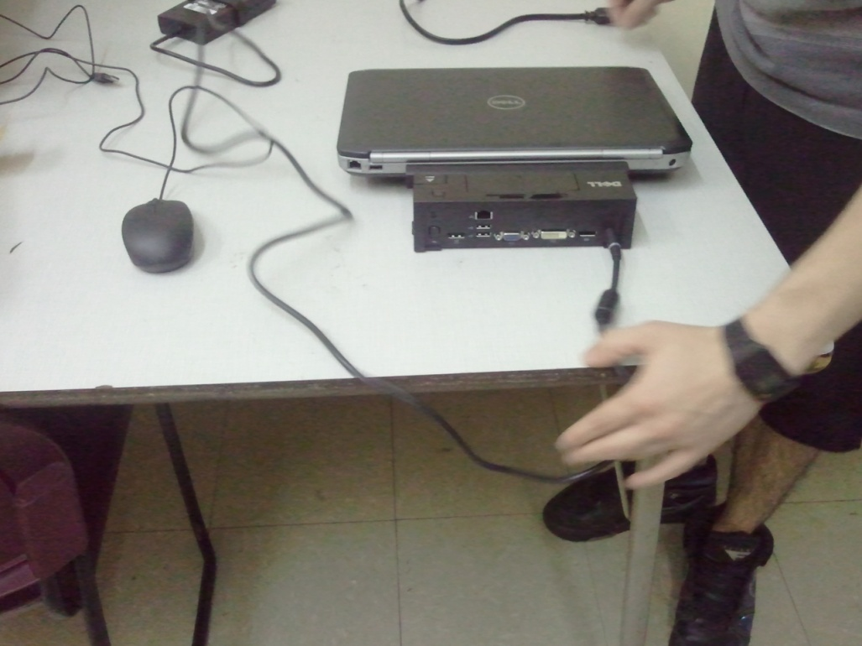

- Connect the mouse and/or keyboard to the back of the Port Replicator.
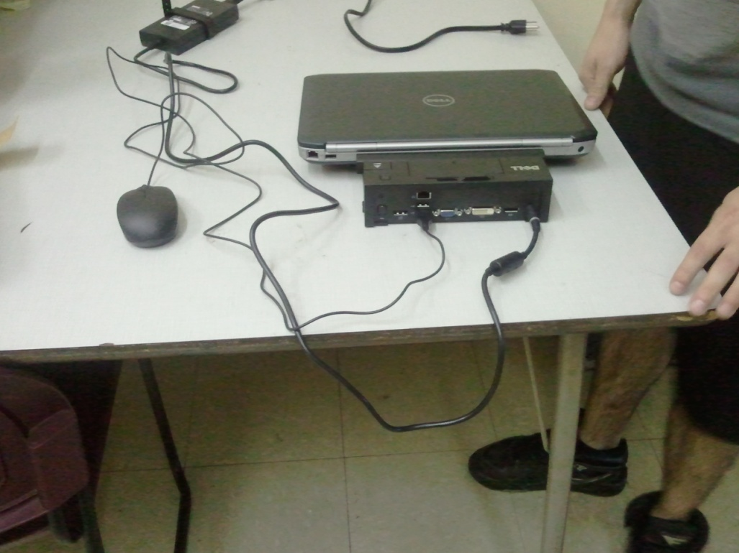

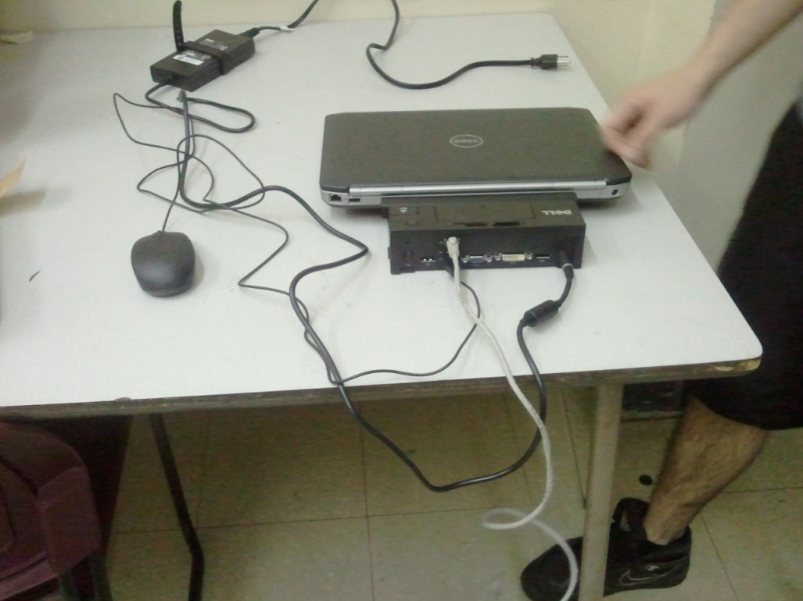
- Connect the network cable (may be black, white, blue, green or grey) to the back of the Port Replicator

Once the Port Replicator has been connected, you should leave it on your desk to avoid connecting it each day and to allow you to easily connect your laptop on a daily basis.

CONNECTING YOUR LAPTOP TO THE PORT REPLICATOR
- The Port Replicator should be facing you (with the cables away from you); attach the Netbook to the Port Replicator ensuring the tabs on the bottom of the Netbook fit snugly into the tabs on the Port Replicator.
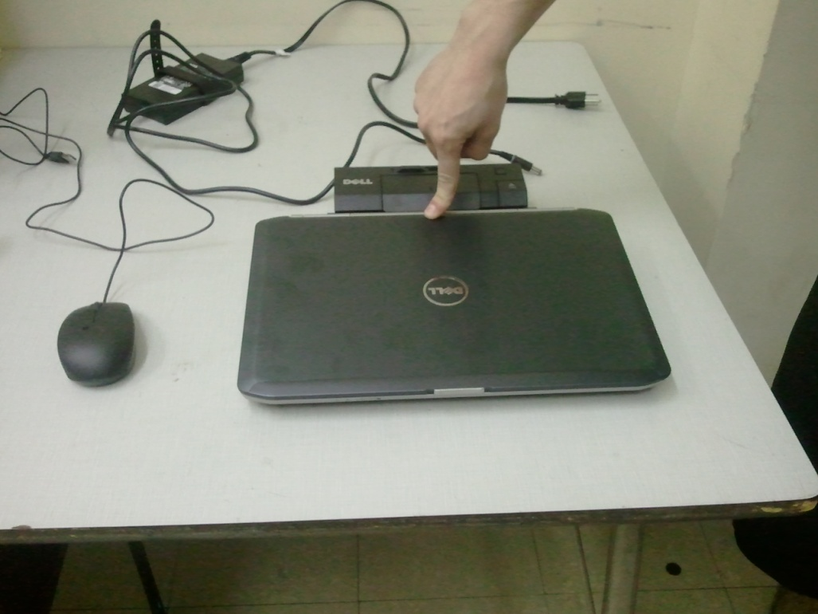

- Open the laptop and power it on.

DISCONNECTING NETBOOK FROM THE PORT REPLICATOR
You can disconnect the Netbook from the Port Replicator to allow you to move around your building and/or take the Netbook home. To disconnect the Netbook:
- Press the button on the right with the arrow on the Port Replicator to release the Netbook. You are now able to remove the Netbook and use it locally. When you return to your office, you should follow the instructions to reconnect the Netbook to the Port Replicator.
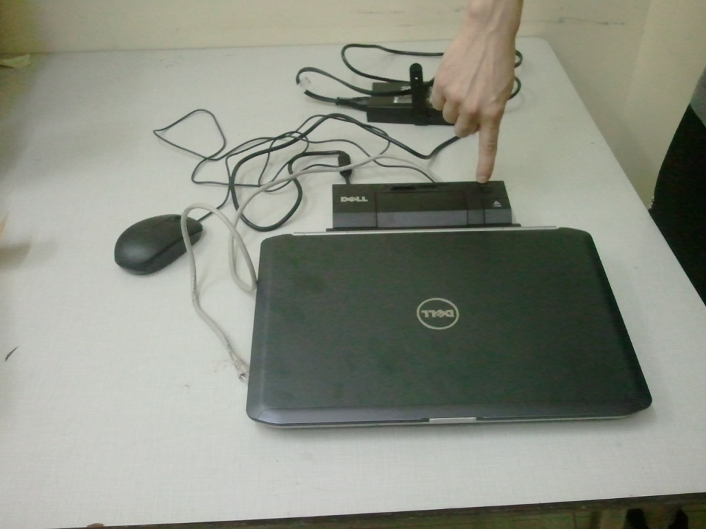

NOTES:
- Although the Laptop/Netbook has been pre-configured with a Local Administrative Account, you should always log onto the CMSD domain using your CMSD logon credentials with a network cable while in a CMSD location, when possible. When disconnected from the network, you should still log on, selecting the CMSD domain with your CMSD logon credentials; however you will only be logged on locally to the laptop.
- The local administrative account will enable you to install software locally on the laptop.
- The local administrative account will enable you to save documents to the hard drive.
  - You should always save your documents to your home directory (i.e. Username$ on HomeDir#) or a SHARED drive you are mapped to. Saving to the Home Directory or Shared drive will enable your documents to be backed up on the network should your hard drive fail.

PLEASE CONTACT THE HELP DESK FOR ADDITIONAL ASSISTANCE/CONCERNS/QUESTIONS:
216-432-6232 or HelpDeskAdmins@cmsdnet.net

