­­­­­­­­­

**Carlisha Bias**

Principal of Whitney M. Young

17900 Harvard Avenue | Cleveland, OH 00000

Office: 216.838.5350 |

**ClevelandMetroSchools.org**

**Chief Executive Officer**

Dr. Warren G. Morgan II

**Board of Education**

Sara Elaqad, J.D.  
*Board Chair*

Robert W. Briggs, J.D.

Robert M. Heard Sr.

Charlene Jones

Midori Lebrón

Denise W. Link

Nigamanth Sridhar, Ph.D.

Diana Welch Howell

**Ex Officio Members**

Michael A. Baston, Ed.D., J.D.

Laura Bloomberg, Ph.D.

**August 1, 2024**

**Re: Cell phone-free school**

**Dear Whitney M. Young Parents, Guardians and Supporters,**

We’re making our schools a phone-free space to improve teaching and learning experiences using a system called Yondr. Yondr has been implemented in over 1,000 schools across 21 countries to facilitate an engaged learning environment.

This change aligns with CMSD’s board policy that states that *“To maintain a secure and orderly learning environment, students who choose to bring a personal cellphone or electronic device to school will have their phone/device subject to collection and/or storage during the student school day.”* This policy follows Ohio House Bill 250, which requires the minimization of cell phone use in schools.

The Yondr Program utilizes a simple, secure pouch that stores a phone. Every scholar will secure their phone in a personally assigned Yondr pouch when they arrive at school. Scholars will maintain possession of their phones and will not use them until their pouches are opened at the end of the school day. They are required to obtain their Yondr pouch each day at arrival and are responsible for their pouch at all times.

We believe that phones have great utility. We have also found that learning and social behavior improve drastically when students are fully engaged with their teachers and classmates. Yondr recently surveyed over 900 school partners to measure the effects of creating phone-free educational environments. These schools achieved notable progress in multiple areas:

• 65% of schools saw an improvement in academic performance

• 74% of schools saw an improvement in student behavior

• 83% of schools saw an improvement in student engagement in the classroom

If you have any questions, please do not hesitate to contact the school directly at 216-xxx-xxxx or attend one of our upcoming meetings about the adoption of Yondr that will occur on our back-to-school Meet the Teacher night on **August 16 from 6:00 pm - 8:00 pm.** In addition, we invite you to look at the attached FAQ document and graphic on how Yondr works.

If there is an emergency and you would like to get in contact with your child, please reach out to the main office at 216-838-5350. To best serve your child, we appreciate your full support in the adoption of the Yondr Program at our school.

Thank you,

Carlisha Bias

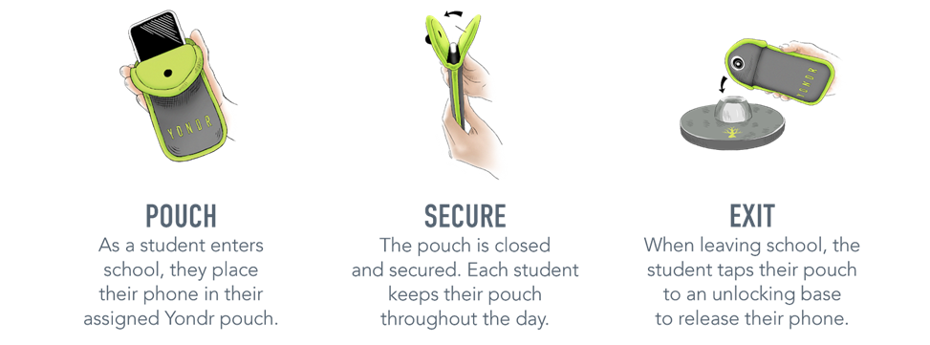

**DAILY PROCESS**

As students **Arrive to School**, they will:

**Frequently Asked Questions**

**What if I want to reach my child during the school day?**

We want our students to be engaged in their learning. If you need to contact your child during the school day, contact the main office at 216-838-6800.

**What if there is a school emergency?**

In case of a school emergency, we direct our students to safety first, following our school emergency preparedness protocol.

**Will my student’s phone be safe?**

Students are in possession of their phones - in their Yondr pouch - for the entire school day. We will advise students to store the pouch in their backpacks where it is completely safe.

**What if the Yondr pouch gets damaged or a student is caught on their phone?**

The Yondr pouch is the property of Wilbur Wright PreK-8 School.

If a student is caught on their phone:

* **1st Offense - Pouch Phone & Message Home.**
* **2nd Offense - Phone Collected & Call Home. Phone Returned End of Day.**
* **3rd Offense - Phone Collected & Held for Parent Pickup and/or Planning Center**

If a student damages their pouch this is considered a level 3 infraction, specifically 3K - Damaging or attempting to damage property, and is a suspendable offense.

**Note:** Damage consists of any signs that the physical integrity of the pouch has been compromised, whether intentional or unintentional, as determined by the school or Yondr staff.

* Turn their phone **off.**
* Staff members will open their Yondr Pouch by tapping against the Unlocking Base.
* Staff members will place their phone inside the Pouch and secure prior to entering the atrium area of the building
* Students will keep their phones with them throughout the day.

As student plan to **Dismiss from the school,** they will:

* At the end of the day, students will hand their pouch to a staff member before exiting the school.
* The staff member will open the pouch and hand the phone to the student but will keep the pouch. All middle school scholars will exit from the *back of the building and be escorted to the front of the building by staff members after this process has ended.*

*Students arriving late or leaving early will pouch/unpouch their phones in the **main office**

**VIOLATIONS**

Pouch Damage / Lost Pouch / Using Phone During School

If a student damages their Pouch or is caught on their phone, Administration will collect the phone/Pouch and call home for a **Parent Pickup, community service/after school detention and a $20 dollar replacement fee.**

Examples of damage:

|  |  |
| --- | --- |
|  | * Ripped * Cut * Torn * Pen/pencil marks * Bent/cut pin * Signs of force to black button on flap |

Additional Information: Responsibility/Liability

 Any student who chooses to bring a cellular phone or other electronic device to school shall do so at their and their family’s own risk. The District and its employees will assume no responsibility or liability for loss, theft, damage or vandalism to a cellular phone or other electronic device brought onto school transportation or property, even during times the phone or device are subject to the collection or storage process of the District. To this end, families are not required to send any personal cell phone or electronic device to school with their student and are encouraged to carefully evaluate all associated risks and benefits when deciding whether to send a cell phone or electronic device to school with a student.

**Offenses:**

**1st Offense – Phone confiscated + Parent Pickup**

**2nd Offense – Phone confiscated + Parent Pickup + 30 Days No Phone**

**3rd Offense – Phone confiscated + Parent Pickup + No Phone Rest of School Year**

**If a student damages their Pouch a $20 fee will be given**