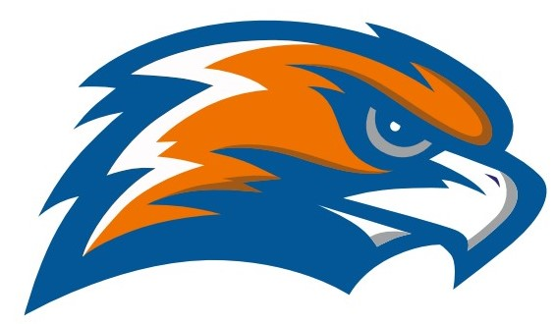

| **GARRETT MORGAN BOWLING 2021-2022** |
| --- |

Head Coach Stuart Philipps Athletic Director Jennifer Smith

Principal GMSEI Quenton Davis Principal GMSLI Anshawn Ivery

| **DATE** | **TIME** | **VISITOR** | **HOME** | **SITE** |
| --- | --- | --- | --- | --- |
| **Monday**  **11/22** | **3:00** | **Garrett Morgan** | **Lincoln West** | **Roll House Brookpark** |
| **Tuesday**  **11/30** | **3:00** | **John Hay** | **Garrett Morgan** | **Yorktown Lanes** |
| **Thursday**  **12/2** | **3:00** | **Glenville** | **Garrett Morgan** | **Yorktown Lanes** |
| **Monday**  **12/6** | **3:00** | **Garrett Morgan** | **bye** | **Roll House Brookpark** |
| **Thursday**  **12/9** |  | **INCLEMENT WEATHER** | **If needed** |  |
| **Monday**  **12/13** | **3:00** | **Garrett Morgan** | **James F. Rhodes** | **Roll House Brookpark** |
| **Wednesday January 12** | **3:00** | **INCLEMENT WEATHER** | **If needed** |  |
| **Thursday**  **1/13** | **3:00** | **Garrett Morgan** | **John Marshall** | **Roll House Brookpark** |
| **Thursday**  **1/20** | **3:00** | **Garrett Morgan** | **East Tech** | **Euphoria Lanes** |

**Inclement Weather - 12/09 and 1/12**

**Practices:** Wednesday and Thursday

Bus leaves GMHS at 4:00 Bus returns to GMHS at 6:30

**Playoffs Senate Championship**

**Monday January 24 Thursday, January 27**

**Roll House @ 3:00 Roll House @ 3:00**

**OHSAA SECTIONALS - February 13 - 20 TBA**

**Senate Athletic League**

**East Tech Garrett Morgan Glenville James F. Rhodes John Hay John Marshall Lincoln West Max Hayes**