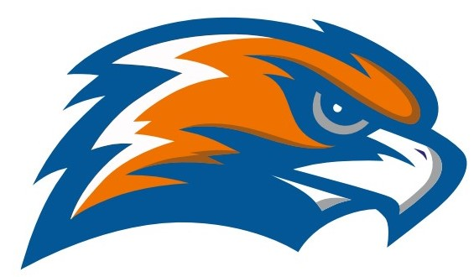

| **GARRETT MORGAN**  **Boys’ Track**  **2022** |
| --- |

**Head Coach Kelly O’Connor Principal GMSEI Quenton Davis Assistant Coach Laura Kraker Principal GMSLI Anshawn Ivery**

**Athletic Director Jennifer Smith**

| **DATE** | **TIME** | **Out of Class/Bus** | **SITE** |
| --- | --- | --- | --- |
| Wednesday  4/6 | 3:30 | 1:50/2:20 | Collinwood |
| Thursday  4/7 |  | 3:15/3:45 | Cuyahoga Heights |
| Monday  4/11 | 3:30 | 1:50/2:20 | Collinwood |
| Thursday  4/14 | 4:00 | 2:40/3:00 | St. Ignatius |
| Thursday  4/21 | 4:00 | 2:40/3:00 | St. Ignatius |
| Thursday  4/28 | 4:00 | 2:40/3:00 | St. Ignatius |
| Tuesday  5/3 |  | 3:20/3:45 | Cuyahoga Heights |
| Thursday  5/5 | 4:00 | 2:40/3:00 | St. Ignatius |
| Tuesday  5/10 | 3:30 | 1:45/2:15 | Jesse Owens Senate Championship |
| Thursday  5/12 | 4:00 | 2:40/3:00 | St. Ignatius |
| 5/16-5/21 |  |  | OHSAA District Meet |