# Mary Mcleod bethune school

## PRE-KINDERGARTEN SUPPLY LIST

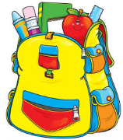

1 back-pack or book-bag (large enough for a pocket folder and lunchbox if sending your child to school with lunch)

1 small blanket (used for nap time)

Package of Tissues

6 large glue sticks

1 container of dry erase markers

1 box of Ziplock sandwich bags

2 boxes of Ziplock gallon bags

2 containers of disinfecting wipes

1 bottle disinfectant spray

2 bottles hand soap

1 change of clothes labeled with child’s name (include: underwear, socks, pants, and shirt – may need to be updated throughout the year once clothes are used)

With gratitude,  
Miss Knauer & Miss Parks