Double click on the speaker icon located in the lower right corner of the system tray to open the ‘Volume Control ‘ window.

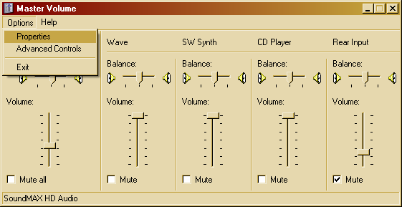

Click the ‘Options’ tab then select ‘Properties’

The ‘Properites’ window will open. Check the box by microphone and click ‘OK’

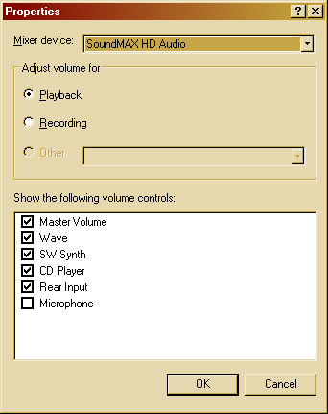 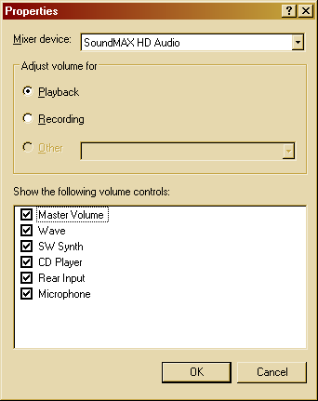

The ‘Volume Control” window be still be opened, simply uncheck the ‘Mute’ box under the

microphone column and close the window.

