To Map a Drive, specifically: K:\@School Principal Folders

- Right Click on your “My Computer” Icon from your desk top

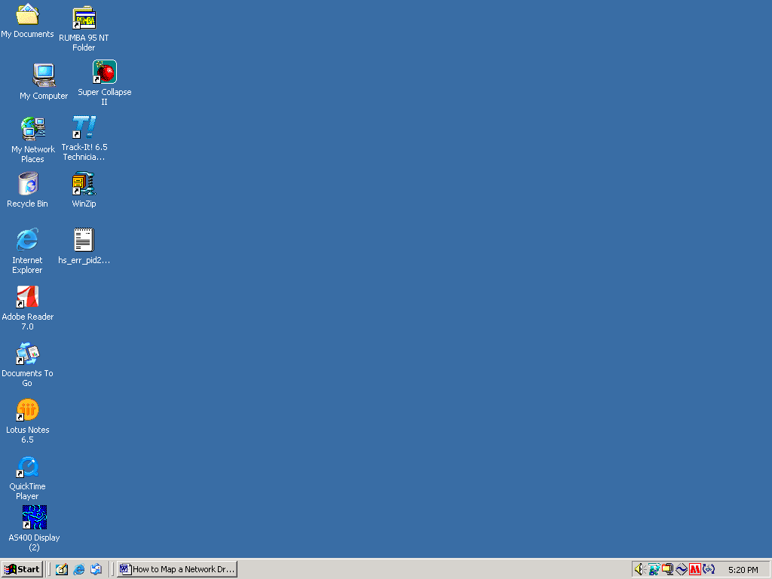

- Click Map Network Drive, and the following dialog box should appear:
- Select “Drive:” Letter K
- Type in the “Folder” Address
\\groupshare7\adminpdc_shared\
- Click the “Browse” Button

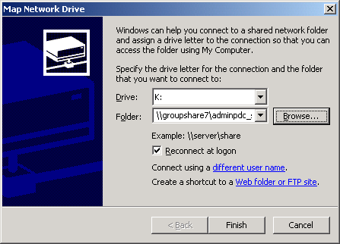

- You should see the following screen:
- Click OK

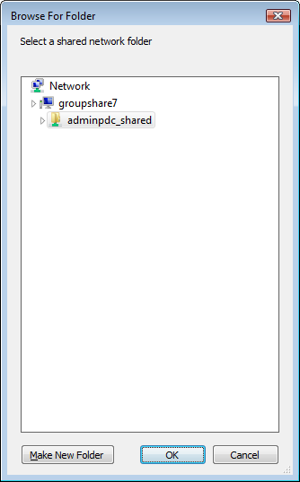

- This returns you to the “Map Network Drive” Dialog box
- Please make sure the “Reconnect at Logon” box is checked
- Click Finish.

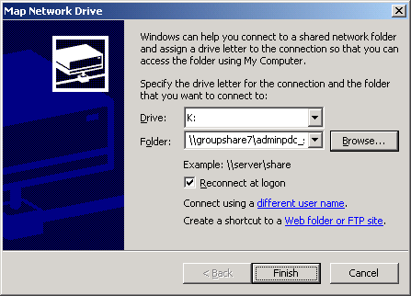

- Open the @SCHOOL PRINCIPAL FOLDERS
- You should see the following:

