**MAPPING TO A NETWORK PRINTER**

**WINXP**

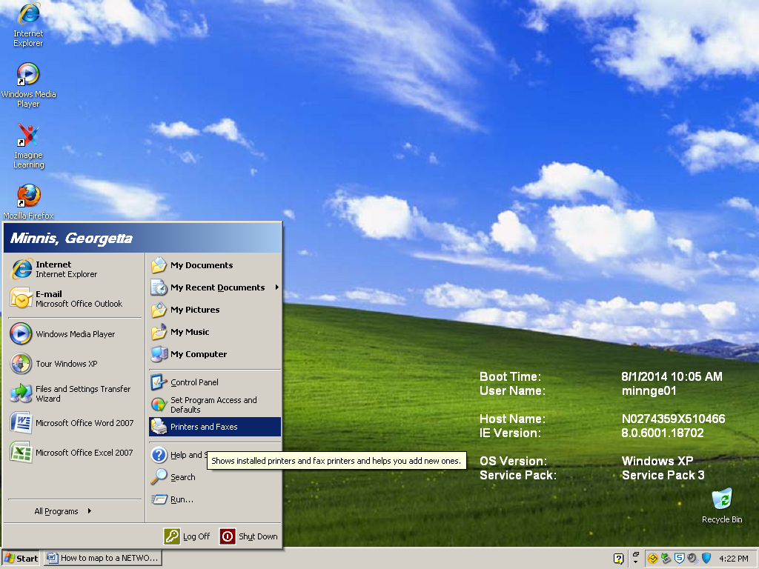

1. Click **Start, Printers and Faxes**

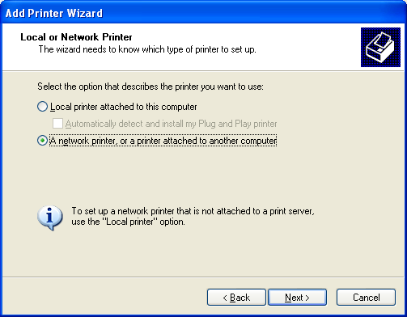

1. Select **A network printer, or a printer attached to another computer**

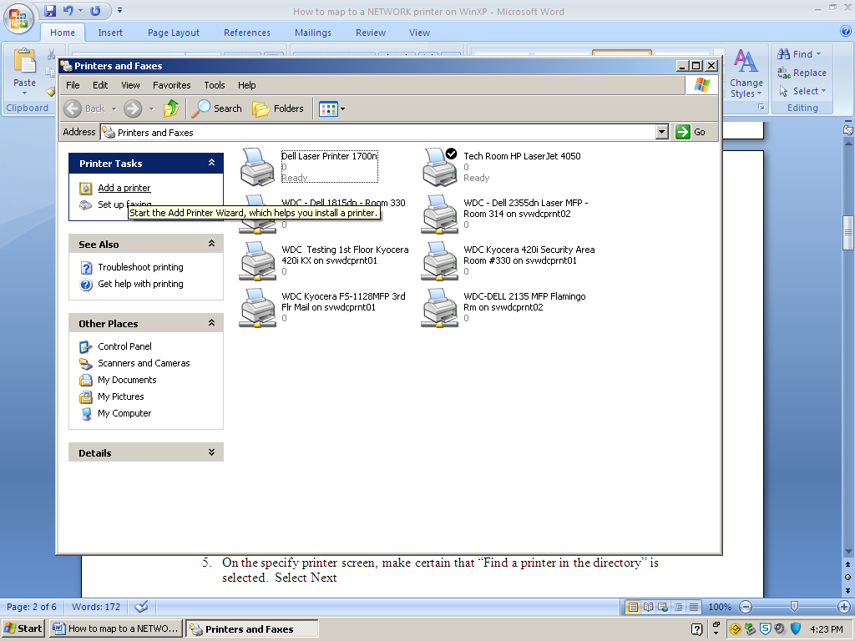

1. Click **Add a printer**

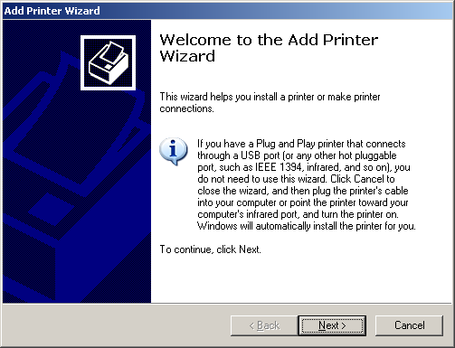

1. Click **Next**

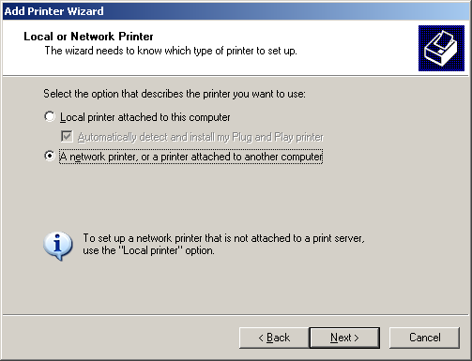

1. Choose **A network printer, or a printer attached to another computer**
2. Click **Next**

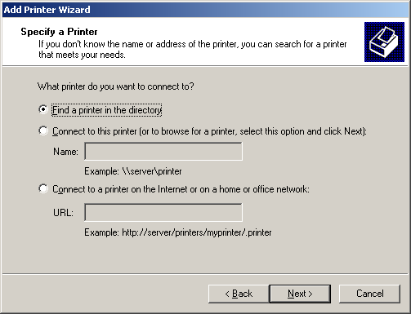

1. Choose **Find a printer in the directory**
2. Click **Next**

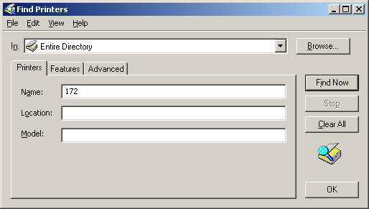

1. Enter the school code number
2. Click Find Now

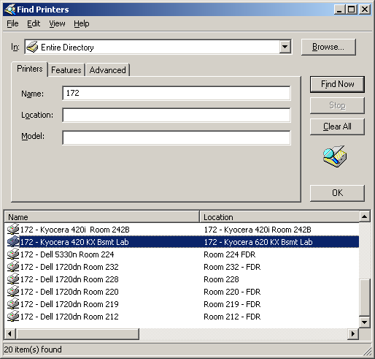

1. Double-click the desired printer

* **IF YOU RECEIVE A PROMPT ASKING YOU TO LOG ON TO THE NETWORK, CONTACT THE HELP DESK TO CONFIRM YOUR NETWORK ACCOUNT HAS BEEN UPDATED WITH YOUR CURRENT SCHOOL ASSIGNMENT.**

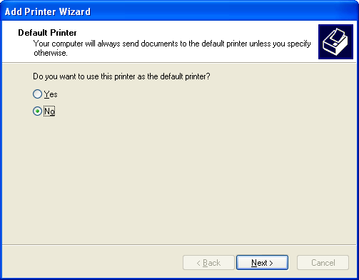

1. Choose Yes to set the printer as the Default Printer if appropriate, otherwise choose No
2. Click Next

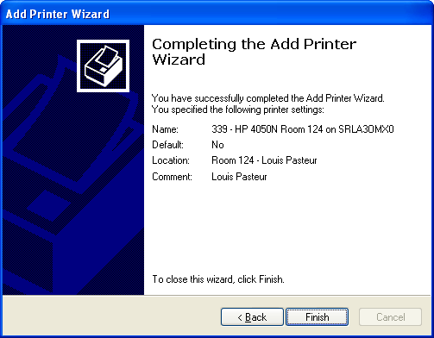

1. Click **Finish**