**How to run the missing script and drives command**

URL: <http://support/Support/>

If a user has drives missing or not mapped.

* The user will go to <http://support/support>.

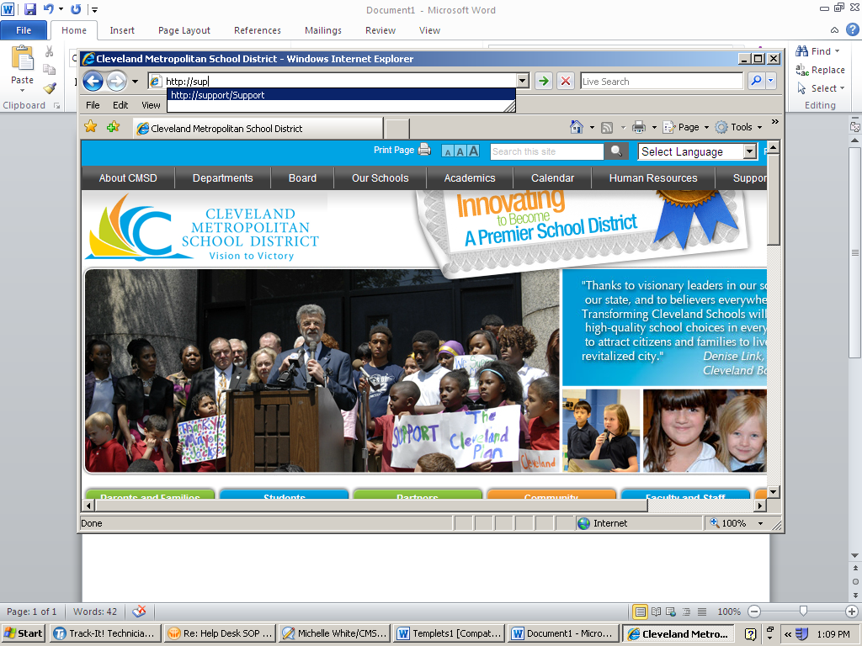

* The user will click on “Run the Logon Script” next to (Drives missing or not mapped).

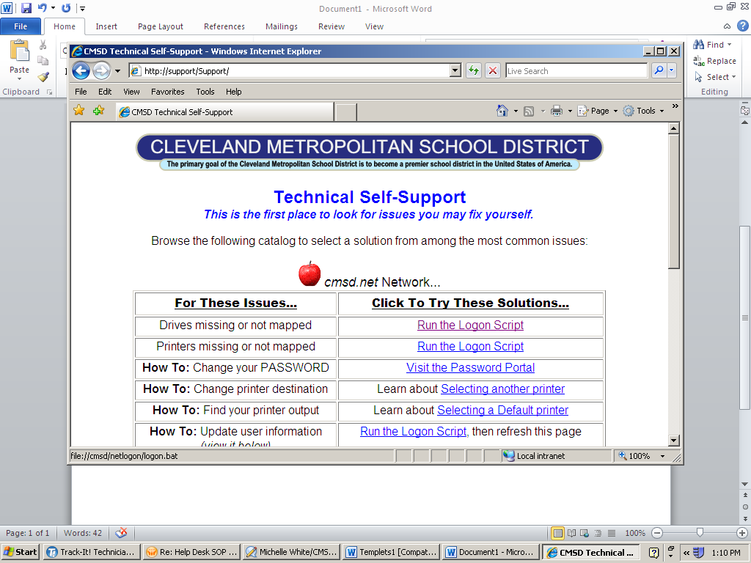

* Then click run.

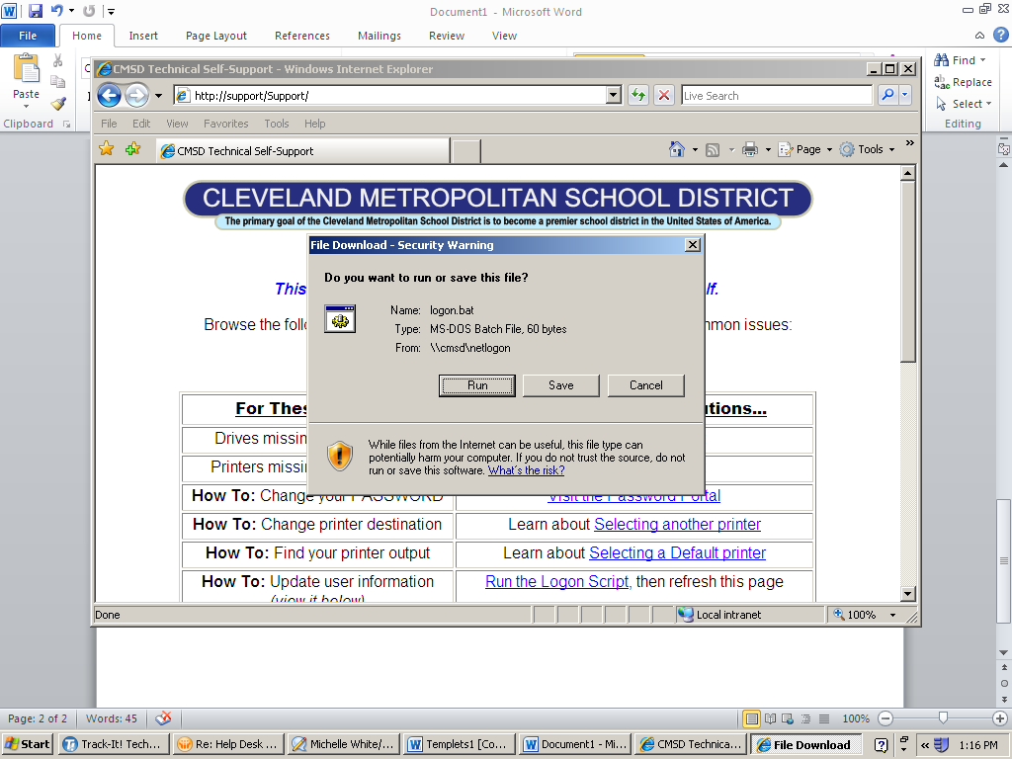

* The user should see a black script box on their screen. Once the script is finished running the box should disappear, or the user can exit out.

The same procedure goes for Printers missing or not mapped.

* The user will go to <http://support/support>.

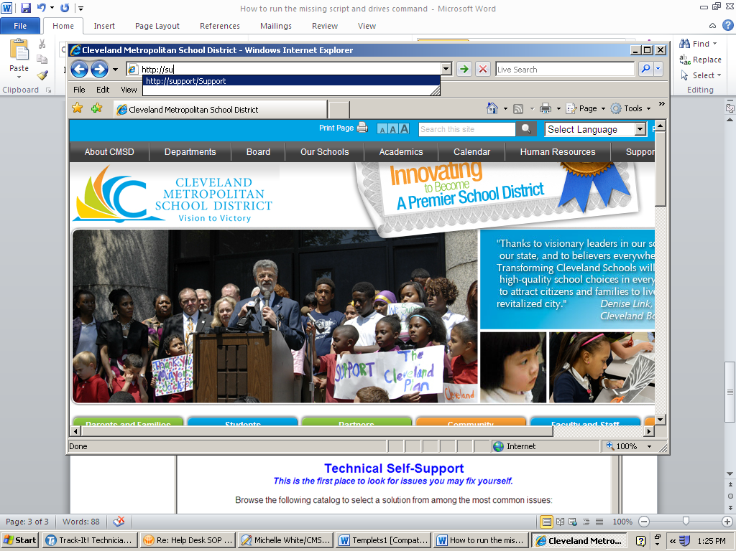

* The user will click on “Run the Logon Script” next to (Printers missing or not mapped).

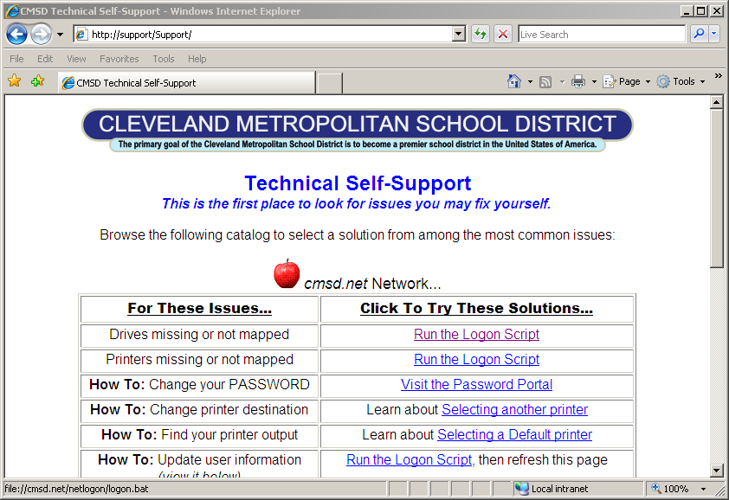

* Then click run.



* The user should see a black script box on their screen. Once the script is finished running the box should disappear, or the user can exit out.