INSTALLATION OF PRINTERS

- Go to Start
- Go to Printers and Faxes
- Go to Add Printer
- Select Next at the Welcome to the Add Printer Wizard

- Select: A network printer or a printer attached to another computer
- Select Next

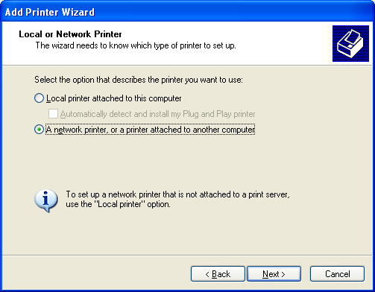

- On the specify printer screen, make certain that “Find a printer in the directory” is selected. Select Next

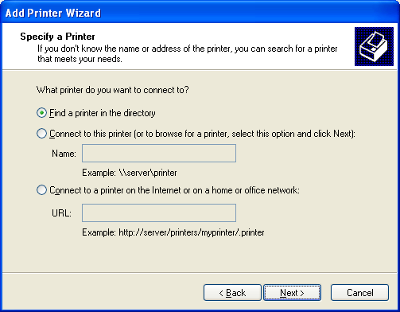

- Type the school code in the Name Box and select Find Now

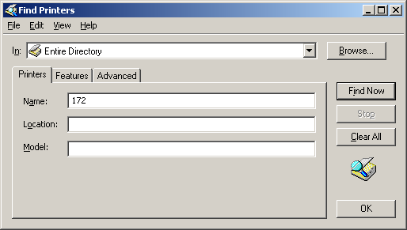

- You should now see the list of school printers. Highlight the printer to print to and select OK

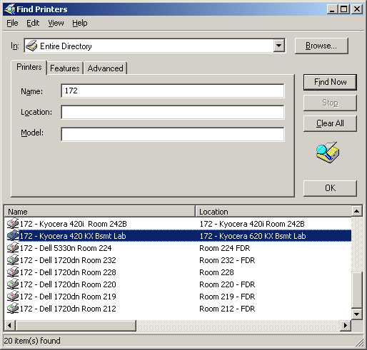

- At the Default printer screen, select if it is to be the default printer and Select next.

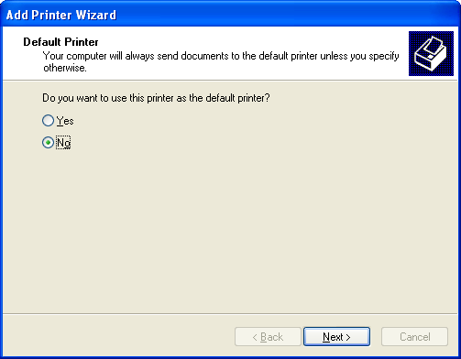

- Click Finish and printer should now be installed.

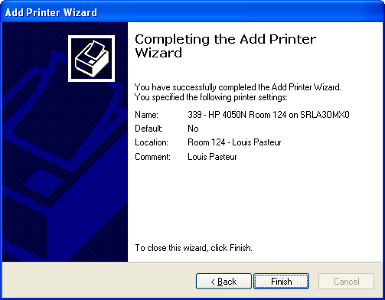
DELETING A NETWORK PRINTER

- Go to Start
- Go to Printers and Faxes
- Left click the printer so that it turns blue (indicating you have selected the printer)
- Hit the Delete key on your keyboard
- Click YES to confirm you want to delete the printer

