Copying Documents from My Documents folder or the Hard Drive to the Home Directory

* Right click My Computer
* Click Explorer
* Click the folder where you have your documents stored (My Documents usually)

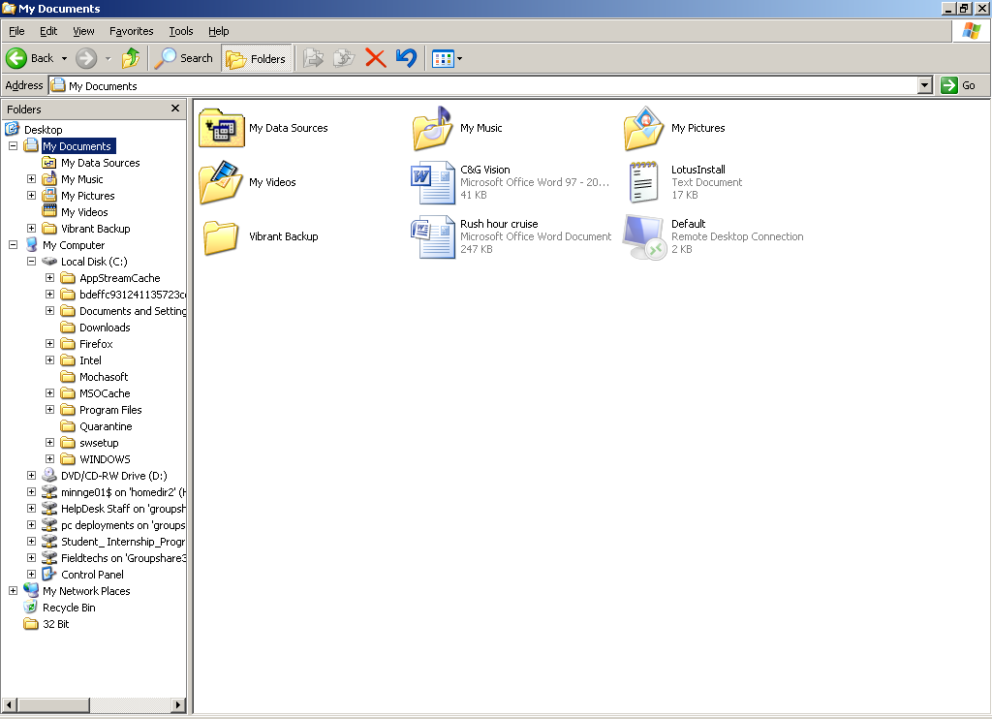

*You want to copy the files from the Desktop, My Documents or C: drive to your Home Directory, which is on the network and is backed up by the network group. If something happens to your hard drive, your files will be saved on the network.*

* You can either drag and drop the folder from My Documents to the drive titled ‘stewci01 on ‘homedir#’ or you can select the folders to copy by selecting one folder then holding the CTRL key and selecting additional folders. Once you have selected the folders to copy, right click and select COPY, then right click your Home Directory and select PASTE.