## 8 STEPS HOW TO LOG IN &

**GET STARTED!**

1. Open a Web Browser and go to

[**https://clever.com/in/cmsd**](https://clever.com/in/cmsd)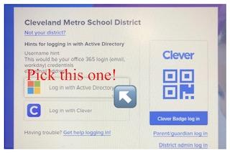

1. Log in with **ACTIVE DIRECTORY**
2. Students will use their **EMAIL** and **PASSWORD** to **LOG IN**. (Password are case sensitive). This password is universally used with just about any academic application in the district. Student email example below…

**STUDENT EXAMPLE EMAIL:** [**firstname.lastname@cmsdk12.org**](mailto:firstname.lastname@cmsdk12.org)

1. Put in your **Email** and press **NEXT**
2. Put in **Password** and press **SIGN IN**

*Click **YES** to give permission to save your information!

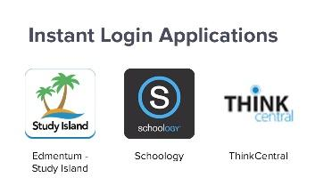

1. WELCOME to **CLEVER Home Page** you will

scroll **DOWN** to **INSTANT LOGIN APPLICATONS**

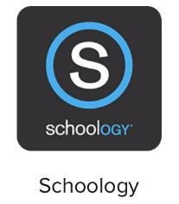

1. Hit **SCHOOLOGY**



Hit the red to make it a favorite and it will appear at the top of the HOME PAGE.

1. Click **COURSES** to find your classes! **YOU ARE IN!**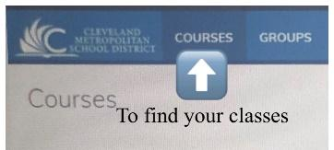

Any issues check out the **HOW TO LOG IN VIDEO** on our **School Website!**