The CMSD Training system is a great place to explore and practice.  This system is populated with actual CMSD data when you use your CMSD ID as your User Name

Use these instructions to get your laptop ready for a demo:

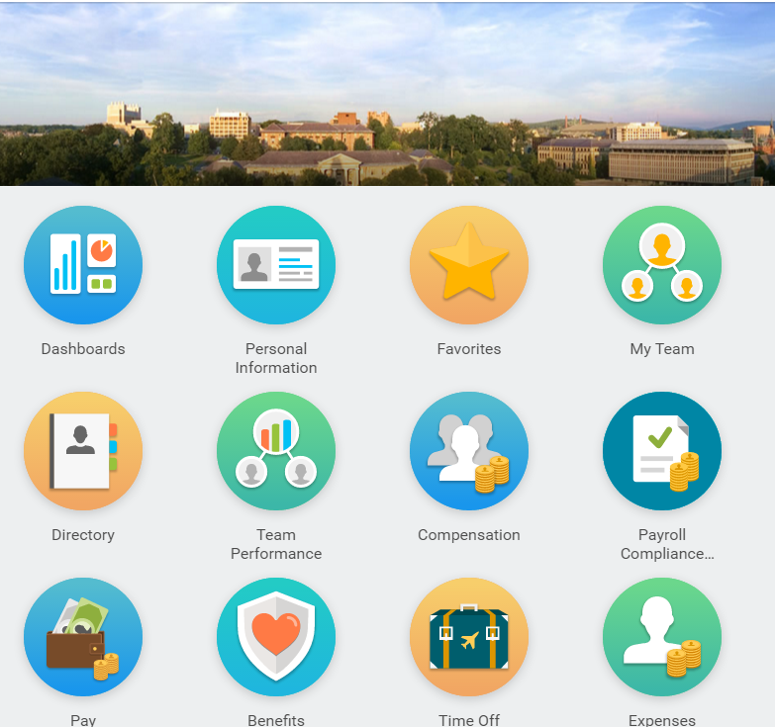Using Desk Top/ Laptop:

Lap top Instructions:

URL: <https://impl.workday.com/clevelandmetroschools4/login.htmld>

Username: **your CMSD ID**

Password: **Cleveland123!** (unless you have already logged into P2—If you have logged into P2 you must use the new personal password you set at that time.)

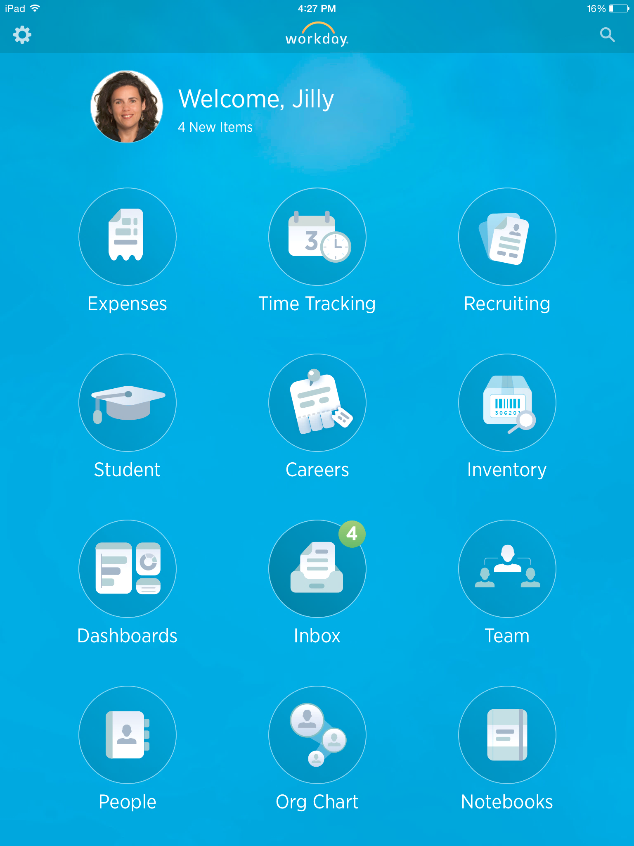Apple iPhone Instructions

1. Download the "Workday" app from the App Store.
2. Select **Access** setting by touching the **gear icon** on the top left corner of the screen.
3. Enter **clevelandmetroschools4** in the Tenant field.
4. Enter <https://impl.workday.com> in the Web Address field.
5. Touch **Save** in the upper right hand corner of the settings screen.
6. Enter the username and password.

Username: **your CMSD ID**

Password: **Cleveland123! (unless you have already logged into P2 and set a personal password)**

1. The worklets and functions on a mobile device are limited. It doesn’t have the full functions of the computer/ laptop web version

Start Demo Here:

Navigate the Home Page

The Workday Home page displays worklets that provide access to tasks and reports. The CMSD home page will be customized by user role.

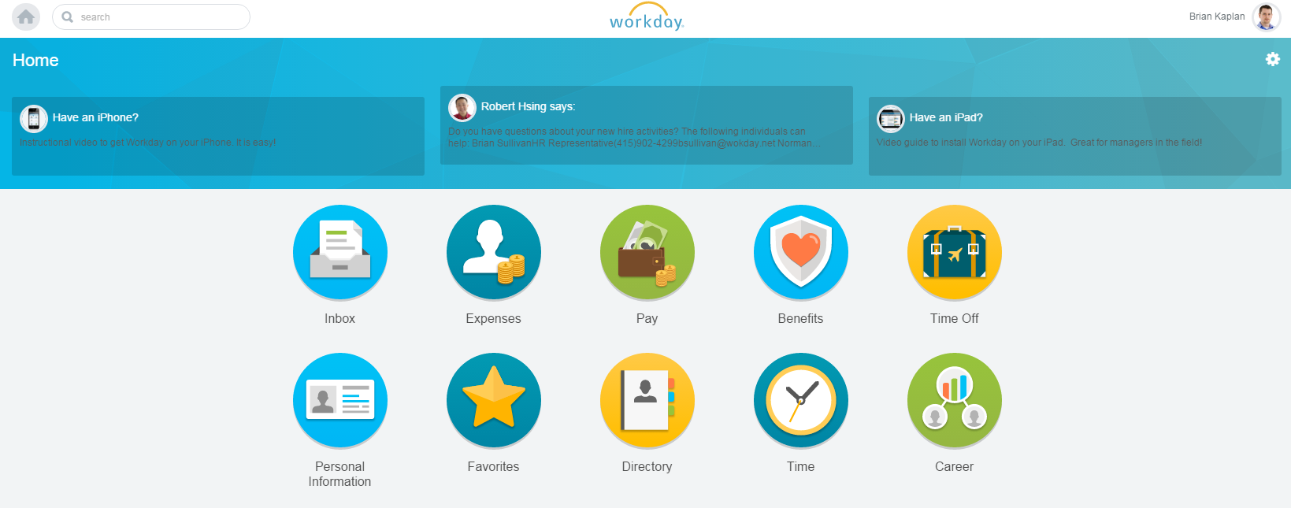

worklets

Clicking the Workday Logo at the top of the page will always take you back to your home page.

View Benefits Worklet

Click the **Benefits** worklet. Behind the worklets you will find options for that function.

Behind the Benefits worklet you can **view** or **change** your information or **link** out to external benefit websites.

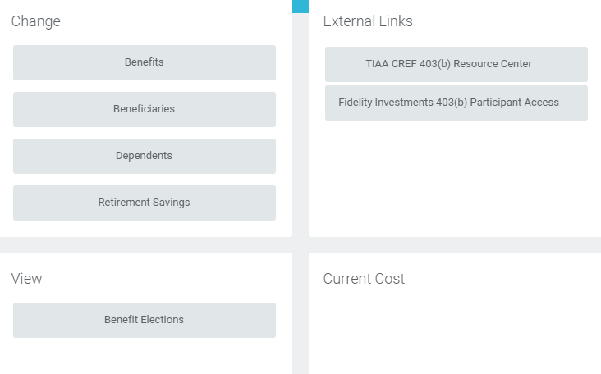

Access Worker Profile Page

1. From the homepage click **Your Profile Icon > View Profile.**

**Or Personal Information Worklet**

1. Your **Worker Profile** page displays. This page is more comprehensive on a computer vs. a mobile device.

The default fields, required fields, fields that require approval and locked fields will be determined by CMSD.

**Jill’s Profile Icon**

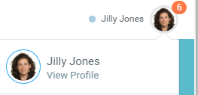

Personal Information Worklet

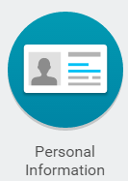

**Profile Page:**

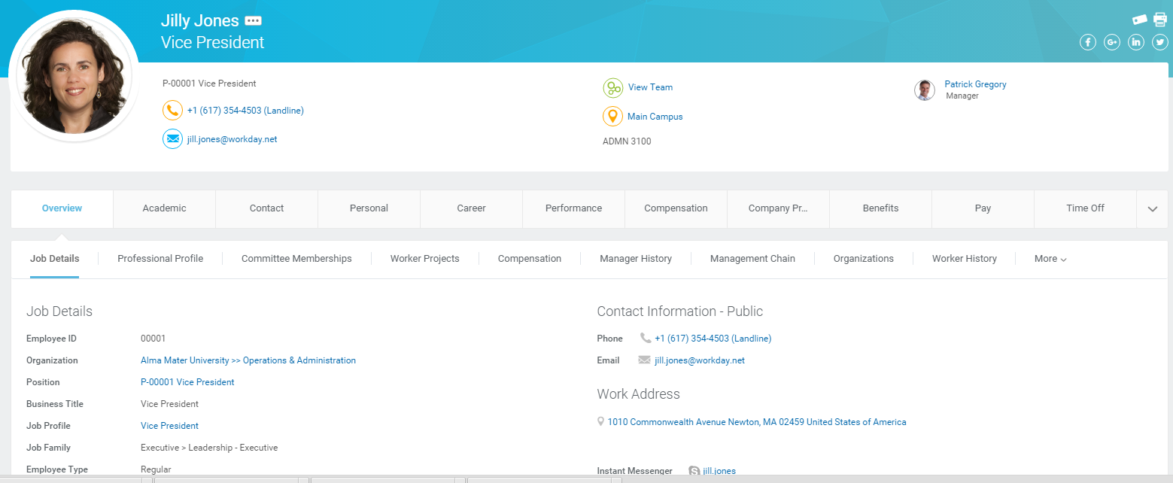

Review Job Details

1. Click your **Profile Icon** > **View Profile**.
2. Click the **Overview** tab.
3. Click the **Job Details** tab. Your position details display.

Job Details include information about your position, organization, length of service and title.

View Transaction History

View your transaction history to see when you enrolled in benefits, changed personal data, etc.

1. Click the **Overview** tab.
2. Click the **Worker History** link. Her business process history displays.
3. Click **View Worker History by Category**.

The data is segmented into different tabs to make it easier for you to review your history.

View Accrued Time Off

From the Home page:

1. Click **Time Off.**
2. Click the **Time Off Balance.**
3. Hit **OK** at the bottom left of the page.

Change Telephone Number

1. From the **Home page** click the **Personal Information** worklet.
2. Click **Contact Information.**
3. Click **Edit.**
4. Click next to **Primary Phone.**
5. Change your phone number and hit **Submit.**

Edit Emergency Contacts

1. Click the **Contact** tab.
2. Click the **Emergency Contacts** link.
3. Click **Edit**.
4. Scroll to **Primary Phone** for your emergency contact.
5. Click **Edit.**
6. Add another phone number for your emergency contact.
7. Click **Submit**.

Locate Org Chart

From the Home page:

1. Click your **Profile Icon** > **View Profile**.
2. Click the **View Team** link.

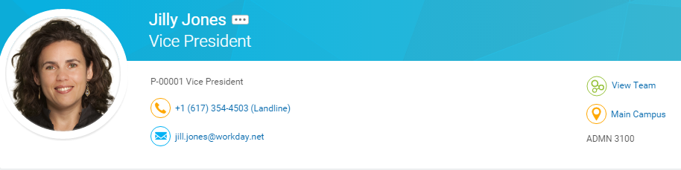

Your Org Chart includes information about your team.

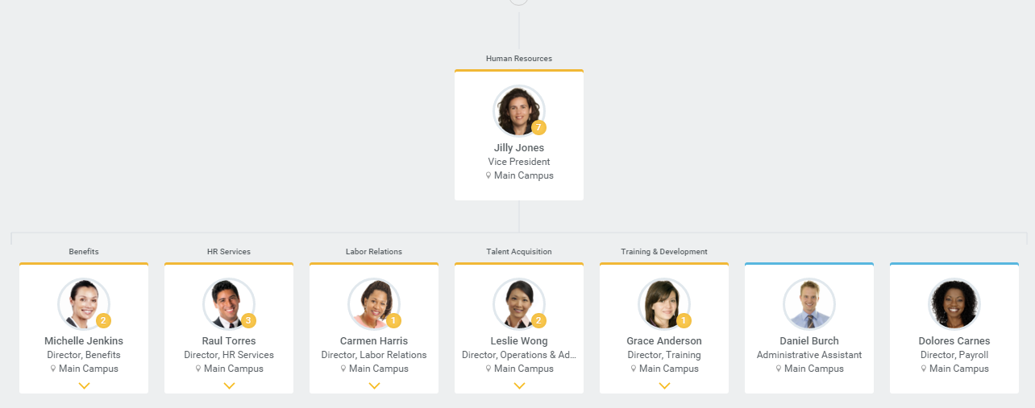

The **small circled number** next to a picture indicates how many direct reports that person has.

**You can navigate up and down the organizational charts.**

**Open Positions** will be shown on the organizational charts. In this example: Jill’s Director of HR Services, Raul Torres, has two open positions on his team:

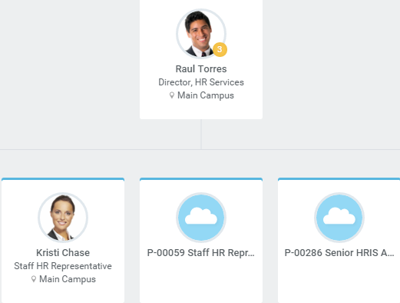

You can **filter for open positions** and contingent workers in the left corner of the organizational chart view:

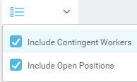

Navigate Using Search

Workday makes it easy to search for people, tasks, reports, and business data using the Search field.

Image of Search Field

For example, to find a worker, type the name (**your name**) into the Search field and press Enter. If you click **People**, you can filter the results to only display workers in your organization. Search categories are used to filter your search for faster, more accurate results.

Keep in mind that searches only find exact matches. If you misspell the search text, you will not see any results. You can use abbreviated terms to find more matches.

1. Enter **“eme con”** for emergency contacts.

When the search results provide what you are looking for, you can either initiate an action using the object’s **Related Actions** Image of related actions icon, or click the link to see more information.

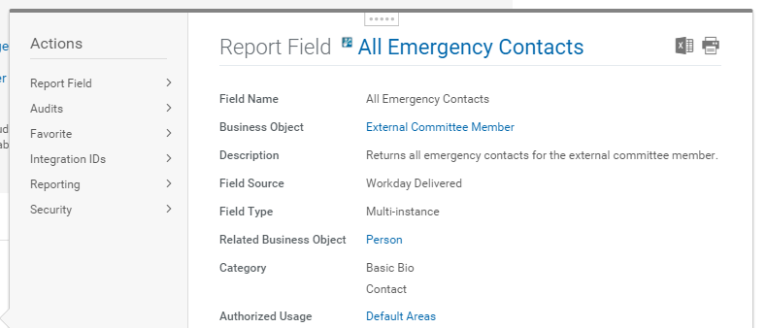

Search prefixes restrict the search results to a particular type of Workday object. Search prefixes are lowercase letters, followed by a colon (:)

1. Enter **“bp: pay”** returns all business processes definitions.

|  |  |
| --- | --- |
|  | To see a list of all search prefixes available to you, enter a questions mark **(?)** in the search box. |

**Manager Reports**

As a manager, Jill has access to certain Dashboard Reports. The reports use real-time data and can be drilled down to show more detail.

**Compensation and Benefits Dashboard**

1. Click the **Dashboards** worklet.
2. Click **Compensation and Benefits.** The compensation. dashboard displays. Look at the **Market Position by Organization** see people compensated above market level.
3. Click on the blue segment of the circle chart. Choose **Employee** to see which employees are above market level.

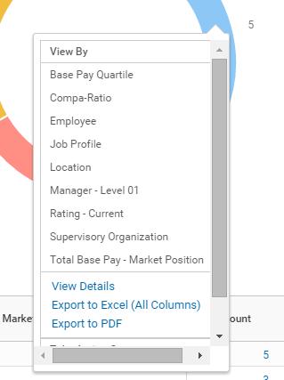

**Change Chart Type**

1. Change the chart type by clicking in the right corner of the chart.

**Recruiting Dashboard**

1. Select **Recruiting Dashboard**
2. Scroll through **All Job Requisitions** to see by title, manager, recruiter, where they job is posted, days aging, etc.

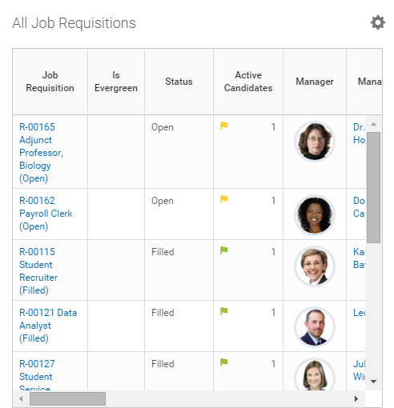

**Mobile Demo**

To explore the CMSD training tenant with a mobile device, please follow the instructions below.

**View/ Change Personal Information**

1. Click your **Profile Icon**. Your profile is a shorter version than on her laptop.

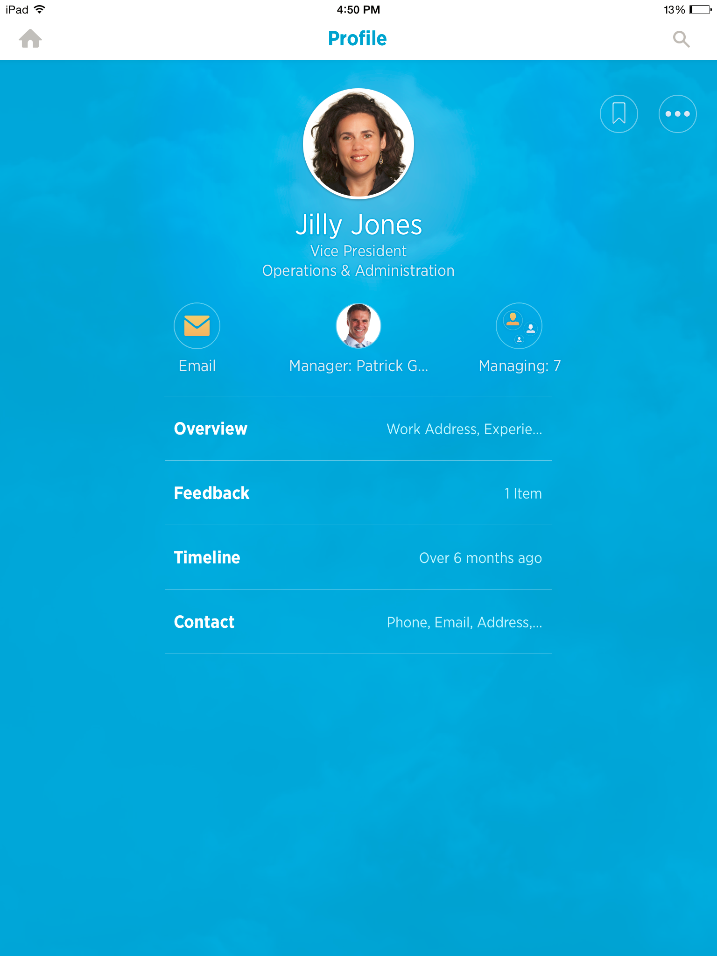

1. Click **Ellipsis** in the top right corner.
2. Choose **Personal** > **Change Contact Information** > **Primary Phone.**
3. Change phone number and hit **Done** in upper right corner of the page.

**Recruiting On the Go**

You can stay on top of recruiting the best talent by using the Workday mobile app on her iPad.

1. Click **Recruiting** worklet > **Prospects.**
2. Select **Nora Chen.** You can see that Nora is a referral.
3. Select **LinkedIn** and you will be taken to Nora’s LinkedIn profile.
4. You can add a **Personal Note** for the Recruiter and the note will be tied to Nora’s prospect record.

**Dashboards**

1. Click the **Dashboards** worklet on your homepage.

You can view the same **Compensation & Benefits** and **Recruiting Dashboards** you viewed earlier on her laptop.